The benefits of joining  the Society:  - Reduced admission to local history and heritage talks  - Access to the History & Heritage Society archives  - The opportunity to hear and discuss planning applications  - You can take part in local history projects and research  - A regular newsletter which keeps you up to date with Society matters and events  - You can support events such as History Days  But how much you want to get involved is up to you.  We appreciate your support and involvement. |  | Name: ……………………………………………………………………………………….  Address: ………………………………………………………………………………………………………………………….  ………………………………………………………………………… Post Code: ………………………….  Tel. N.:  Telephone Number  Address: ………………………………………………………….…………………………………………………………… | Telephone Number: ……………………………….……..  ee  E-Mail  EE  E  E-Mail:  E-Mail:  E-Mail: …………………………………………………………….. | E-Mail: ……………………………………………………………. | - 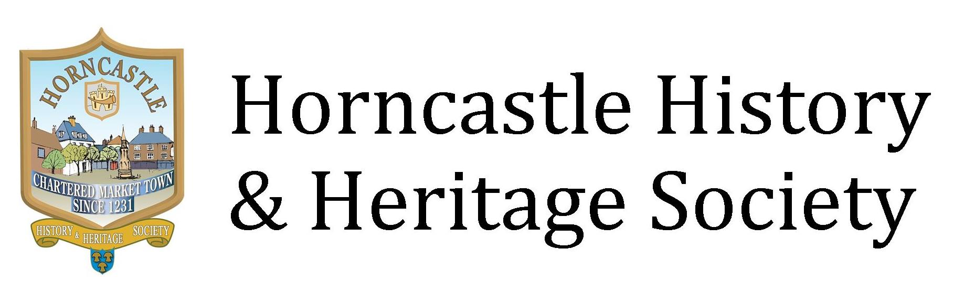  MEMBERSHIP  FORM  Protecting Horncastle’s  Past  Present & Future  Registered Charity No.: 1082147

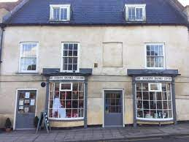  Location  The Horncastle History & Heritage Society is located in the Sir Joseph Banks Centre building.  The centre is open to visitors to the town and is staffed by volunteers from the Sir Joseph Banks Centre and the History & Heritage Society.  Subscription  Please forward a cheque for £20 for family or £15 individual (made payable to Horncastle History & Heritage Society to us at:  Horncastle History & Heritage Society  c/o Sir Joseph Banks Centre  7 – 13 Bridge Street, Horncastle  LN9 5HZ | Or you can pay by bank transfer to our account (please use your name as a reference):  Sort Code: 30 – 99 - 50  Account No.: 35862760  GIFT AID: If you pay income tax or capital gains tax, then the Society can reclaim that tax from HMRC on any donations you make to us. Please sign below:  I want Horncastle History & Heritage Society to treat all donations I make from 6th April 2025 as Gift Aid donations. I confirm that I am a UK Taxpayer.  Signed  ……………………………………………  Date: …….. / …….. / …………….  Please tick the box if you  consent to Horncastle  History & Heritage Society  holding your personal details on file for the purposes set out in our Constitution and in compliance with data protection legislation

CONTACT US

E-Mail: horncastlecivic@gmail.com

Website

www.horncastlehistory.co.uk

Joseph Banks Centre website:
www.joseph-banks.org.uk

